8] Join Queries:1)Inner join 2)Outer join

========================================================================
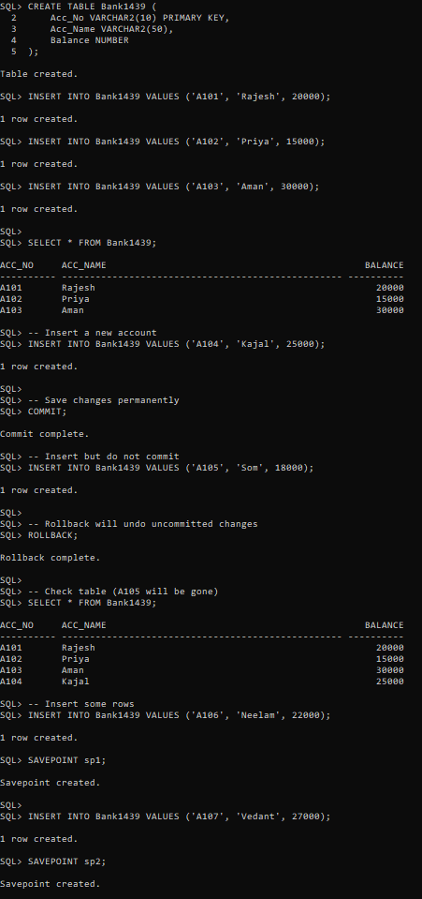
OUTPUT:

